Student Analytics with AI-Powered Agent Attendance System for IoT Smart Library

Lokanath Reddy Chilakala
Assistant Professor, Dept. of ECE
G Pullaiah College of Engineering and Technology
Kurnool, Andhra Pradesh, India
chilakalalokanathreddy@gmail.com

Kummari Bhuvanesh
UG Scholar Dept. of ECE
G Pullaiah College of Engineering and Technology
Kurnool, Andhra Pradesh, India
bhuvaneshkummari@gmail.com

Mangali Ramesh
UG Scholar Dept. of ECE
G Pullaiah College of Engineering and Technology
Kurnool, Andhra Pradesh, India
rameshmangali2004@gmail.com

Ajay Roy
Department of Electrical Engineering
College of Engineering
University of Bisha, Saudi Arabia
aroy@ub.edu.sa

MD Fayaz
UG Scholar Dept. of ECE
G Pullaiah College of Engineering and Technology
Kurnool, Andhra Pradesh, India
shaikmdfayaz23@gmail.com

Abstract— Managing physical resources like libraries in modern universities is often hindered by outdated manual logs or simple spreadsheets that fail to provide real-time data. We developed an IoT-based Smart Library Attendance System that uses Artificial Intelligence to move beyond basic record-keeping. Our hardware design uses 13.56 MHz RFID technology for fast, contactless user identification. At the core of the system, an ESP32 microcontroller uses its dual-core architecture to manage sensor polling and Wi-Fi data transmission at the same time, preventing network lag from slowing down user interaction. For the backend, we chose the MERN stack because its non-blocking event loop can handle many students at once during peak hours. Our system's standout feature is the "Hybrid Intelligence" agent, a collaborative technology combining human expertise with advanced artificial intelligence to deliver a truly distinctive approach to problem-solving. This agent sends student logs to the Google Gemini API to generate personalized study advice, but it also includes a local JavaScript-based fallback to ensure the system keeps working even if the internet fails. During a 14-day test with 50 students, the system achieved 100% accuracy and a very low average response time of 1.15 seconds. This project demonstrates how inexpensive IoT hardware can be turned into a powerful academic tool.
Keywords— Internet of Things (IoT), Radio Frequency Identification (RFID), Educational Data Mining, ESP32, MERN Stack, Generative AI, Hybrid Computing, Smart Campus

Introduction
The "Smart Campus" concept is by far one of the most important concepts in the design of modern educational institutions. A library is still an essential element of cognitive growth; however, the traditionally managed and administered library typically uses outdated means of operation. Library administrators often rely on manual data collections or use separate, outdated systems that perform data storage like "write-only" files: they capture the information, but only infrequently review it.

A. The Problem Space
The current technological solutions face three significant challenges of:
Latency and Hygiene: Although fingerprint and iris scan technology is a secure method to confirm a user's identity, it is a slow process during peak use periods. A typical fingerprint confirmation might take 3 to 5 seconds when factoring in the time it takes for the user to place their finger on the reader and for the reader to pause and process the information [1]. Moreover, the shared surface touches associated with fingerprints and irises are contrary to recommended public health assessment guidelines established following the COVID-19 pandemic [2].
Data Scalability: Local RFID systems usually keep data on local servers like MS Access or SQL databases. This setup does not allow for remote real-time monitoring and requires physical access to generate reports. [8].
Lack of Cognition: The most important gap is the lack of insight. To say that "Student A arrived at 9:00 AM" is factual information. To say that "Student A has arrived at 9:00 AM every day for a month" is knowledge. The existing systems do not fill this gap between data and knowledge.

B. Proposed Solution
This paper develops a unified model that addresses the above issues through the convergence of IoT and AI. The data is then transferred to a cloud-native database, which makes it accessible from anywhere in the world. More importantly, we present an Intelligent Analytics Layer that interprets raw attendance logs to give qualitative feedback to the student, thereby transforming the attendance system into a passive academic advisor.

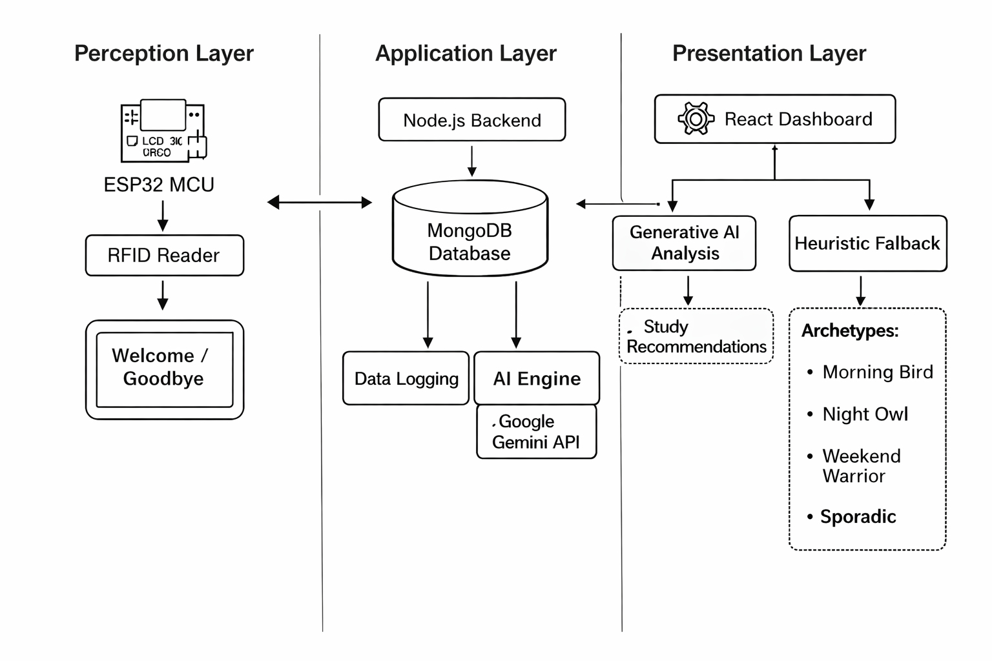
Fig. 1. Basic outline for how this mechanism will work

LITERATURE SURVEY
For the purpose of situating the work at hand, a quick review of the present methodologies was carried out.

A. Biometric Authentication Systems
For classroom attendance, Zainal et al. (2014) used fingerprint sensors interfaced with Arduino microcontrollers [5]. They highlighted the low cost of optical sensors such as the R307 in their study. Additionally, they reported a "False Rejection Rate" (FRR) of about 5% due to different skin conditions, such as cuts, sweat, or dryness. A 5% rejection rate would lead to long lines and irritated patrons in a busy library. Similarly, Jacobs et al. (2018) investigated the use of facial recognition to track attendance [6]. Large libraries that use natural light often have these systems, which are not contact-based but need a lot of processing power and struggle with various lighting conditions. Concerns about privacy related to the keeping of biometric templates also represent a major ethical hurdle [7].

B. RFID Verification Systems
Sharia and Haque (2016) presented a standalone RFID system. Their architecture was strong but limited by its topology; the reader communicated via UART to a local PC. If the PC failed, then the whole system would go down. In addition, it could only analyze data in terms of summation (total hours), without any behavioral interpretation.

C. IoT-Cloud Integrations
P. K. N et al. (2019) brought this up to date with integration of ESP8266 Wi-Fi module. Their system pushed data to Google Sheets. It solved the "Data Silo" problem, but Google Sheets is not a scalable database for long-term institutional data because it has no relational integrity and query optimization.

D. Summary of Gaps
The literature review shows a clear path:
Manual → Biometric → Local RFID → Cloud IoT.
But there is “Intelligence” step missing. No system found in any of the reviewed literature used Generative AI to interpret the attendance logs back to the user. That is what this paper seeks as a new frontier.

THEORETICAL FRAMEWORK AND ARCHITECTURE
The architecture is a distributed system, with three separate logical layers, namely, Perception (Edge), Persistence (Cloud), and Processing (AI).

A. The Edge Node: Hardware Specifications
The Edge Node Hardware interface is based on the Espressif ESP32- WROOM-32 MPU Module.
Microcontroller Architecture: The ESP32 contains a dual-core, 32-bit Tensilica Xtensa LX6 microprocessor. Core 0 is dedicated to handling the protocol stack of WiFi/TCP/IP, whilst Core 1 is handling application requests such as polling RFID readers and updating the LCD. This model allows for the fact that latency on the network will not affect how quickly the user can interact with our application [10].
RFID Reader communication: The MFRC522 communicates over the Serial Peripheral Interface (SPI) bus. The speed of the SPI bus is set to 4 MHz to ensure proper signal integrity on the PCB tracks. The reader generates an electromagnetic field at 13.56 MHz frequency; when a passive tag (Mifare 1K) enters this field, it uses inductive power to transmit its UID, which consists of 4 bytes.
Visual Interface: A 16x2 Liquid Crystal Display (LCD) connected via a PCF8574 I2C expander reduces the number of required GPIO pins from six to two (SDA, SCL), simplifying layout design.

B. The Application Layer:
MERN Stack The application server was developed on the MERN stack because all components are using JavaScript on the front-end and backend.
Runtime environment: Node.js uses V8 JavaScript Engine as the runtime environment for Node.js. Node.js has an efficient non-blocking event loop that allows for thousands of concurrent requests to be handled and processed in an async fashion, without blocking the critical threads [12].
Data Persistence: MongoDB Atlas is used as our managed cloud-based Data Persistence solution. To handle large write operations efficiently, the MongoDB database’s schema has been designed to accommodate this.
- Student Collection – Static Metadata: name, Roll Number, and CardUID.
- Collection attendances: a Time-Series style collection storing granular events.

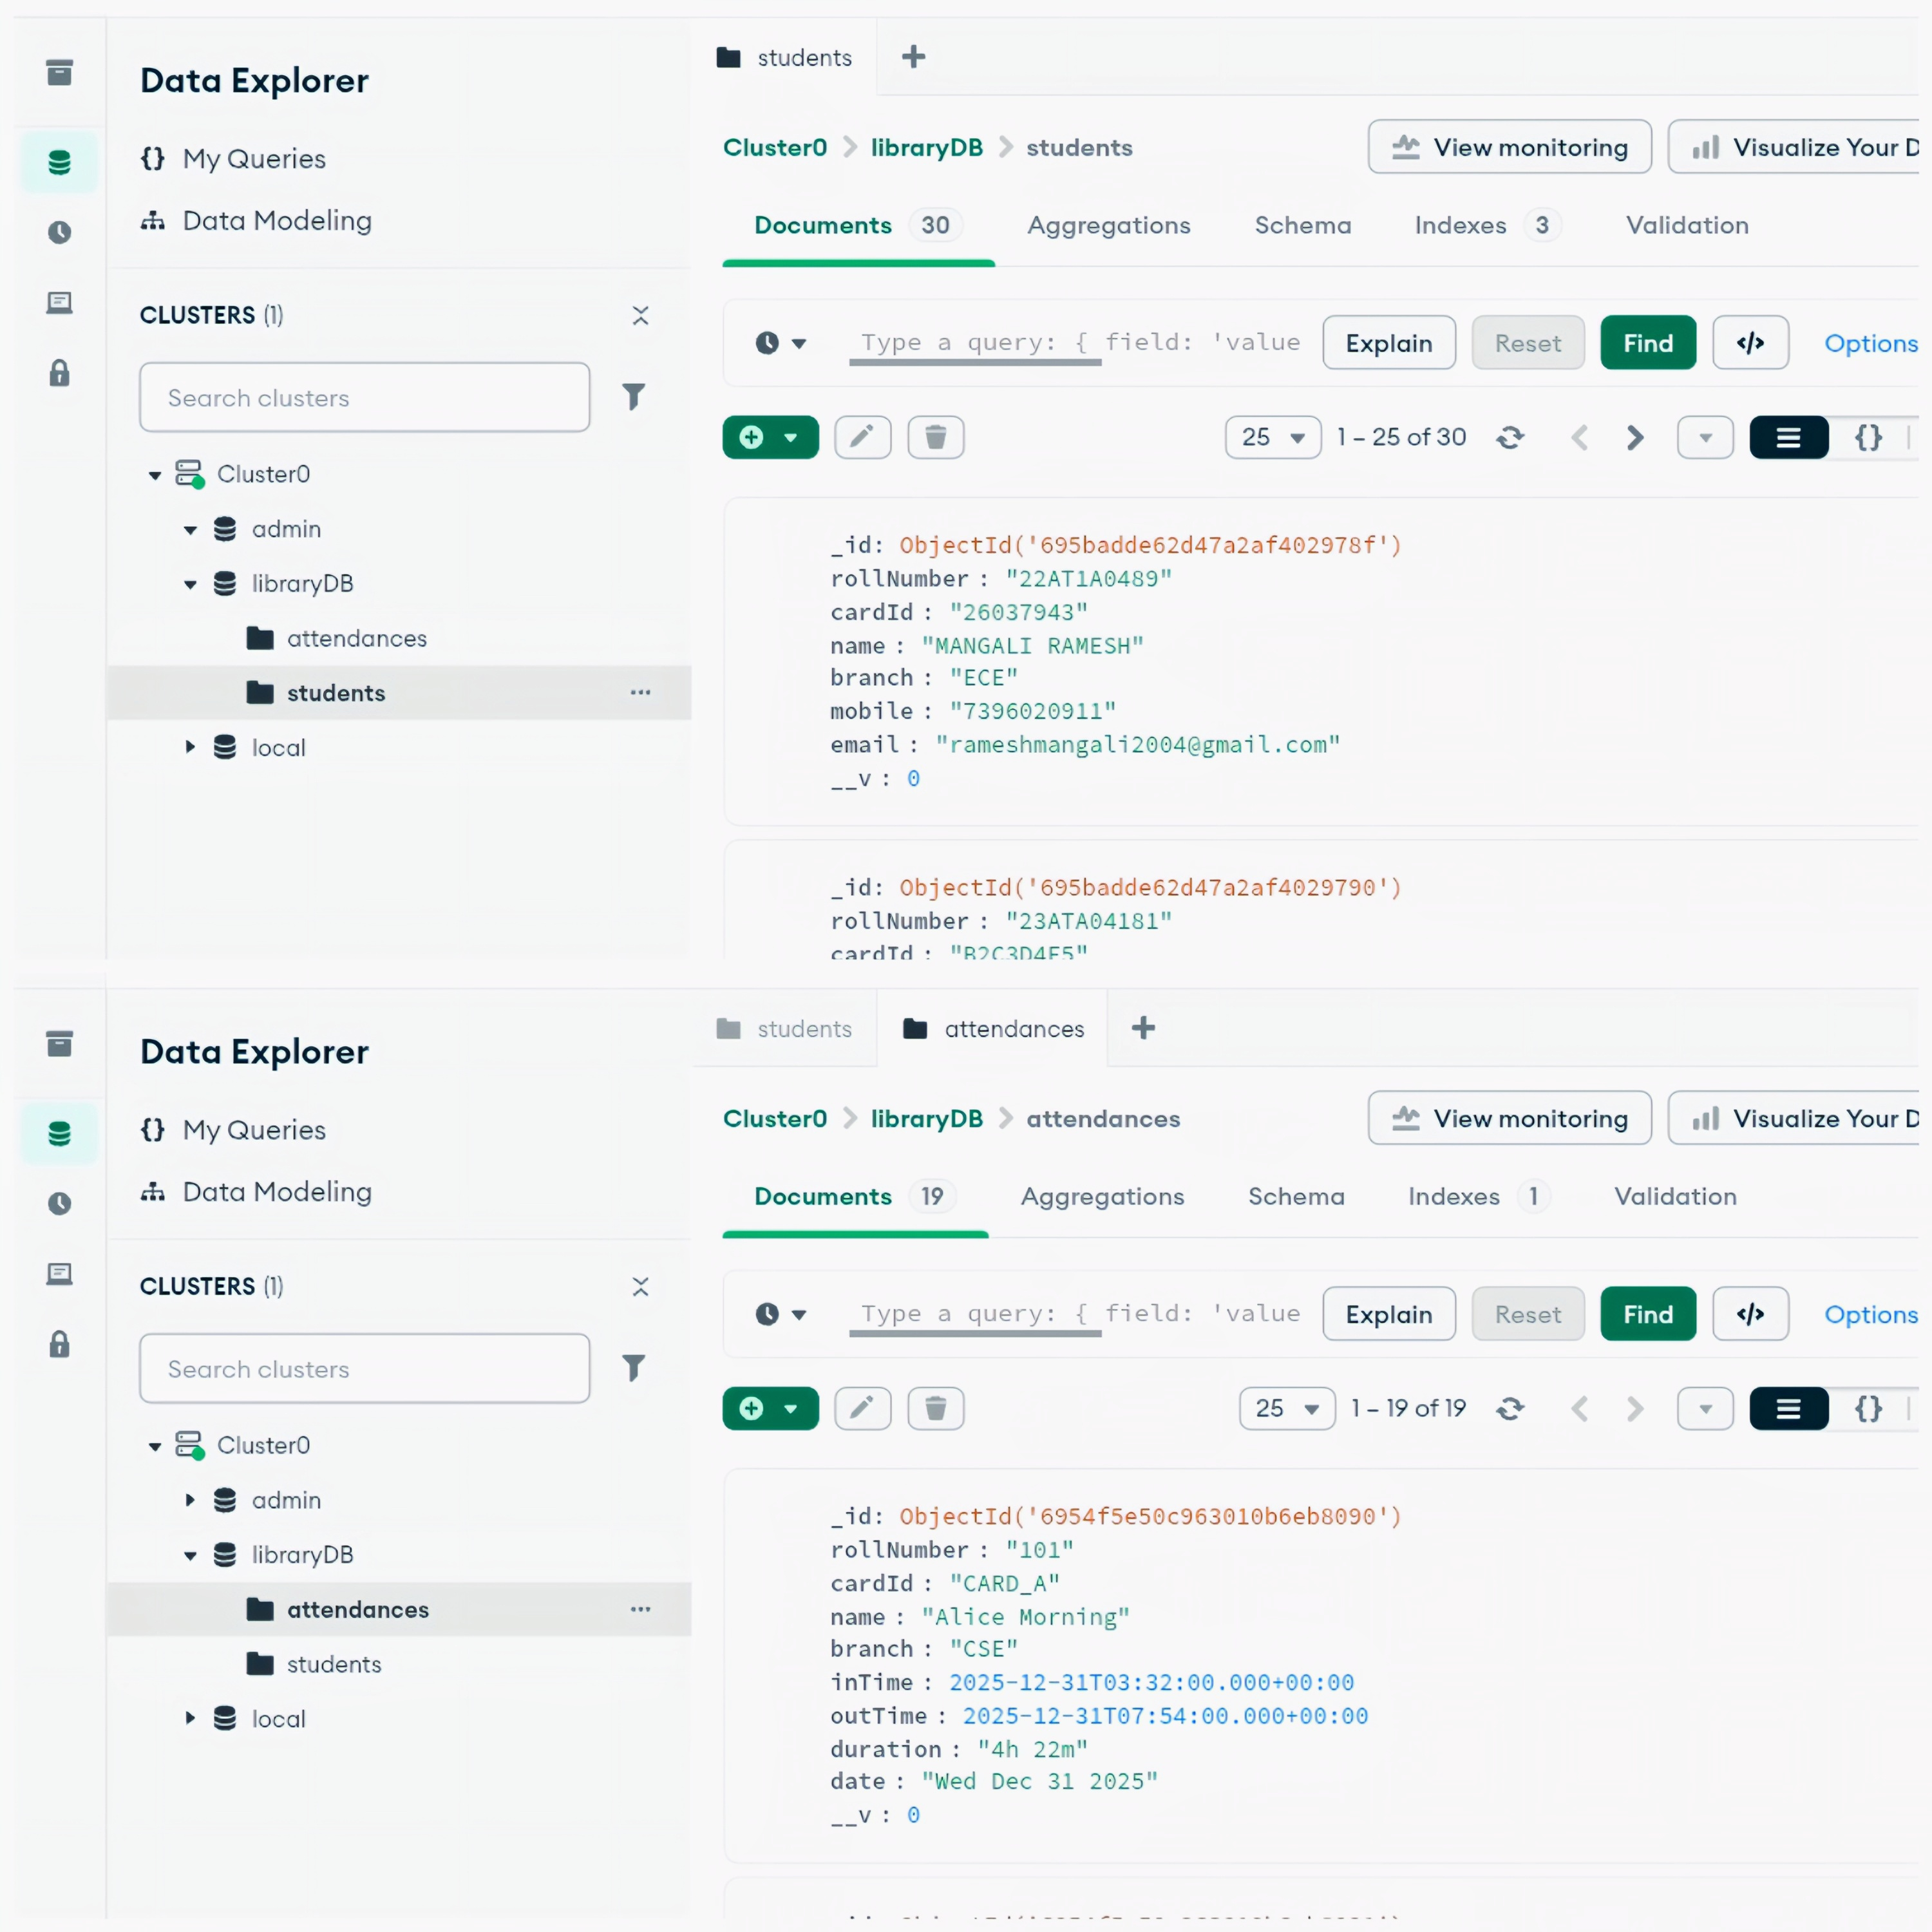
Fig. 2. Data Explorer view of the MongoDB Atlas database showing the students collection for static student information and the attendances collection for time-series attendance records.

C. The Intelligence Layer: Hybrid Logic
This is the main difference in our system. It works in two modes:
Mode A: Generative Inference (Online): The system creates a contextual text prompt from the user’s last 30 days of logs and calls the Google Gemini API. As a result of using the LLM, it will be able to determine if the student is studying consistently on a daily basis, or cramming just before exams and will provide general advice.
Mode B (Deterministic Heuristics): In the case of a network partition or during API rate limiting, a JavaScript-based statistical analysis will be used to determine the mode of entry hours and variance of session lengths and will categorize students into buckets such as Consistent, Sporadic, and Late Worker.

SYSTEM IMPLEMENTATION DETAILS
A. Hardware Interfacing
The hardware integration focuses on reliable connections between the 3.3V logic level of the ESP32 and the peripherals.
SPI configuration for MFRC522: MFRC522 requires a strictly timed start-up sequence; firmware first performs “Soft Reset” on reader chip then sets antenna gain to maximum (48 dB) in RFCfgReg register to maximize detection distance.
Wi-Fi state machine: To prevent hangs, logic for Wi-Fi Connection is non-blocking checking status every loop iteration if disconnected attempting reconnection without distinct delay ensuring RFID reader stays active though unable to upload referred to as “Graceful Degradation.”

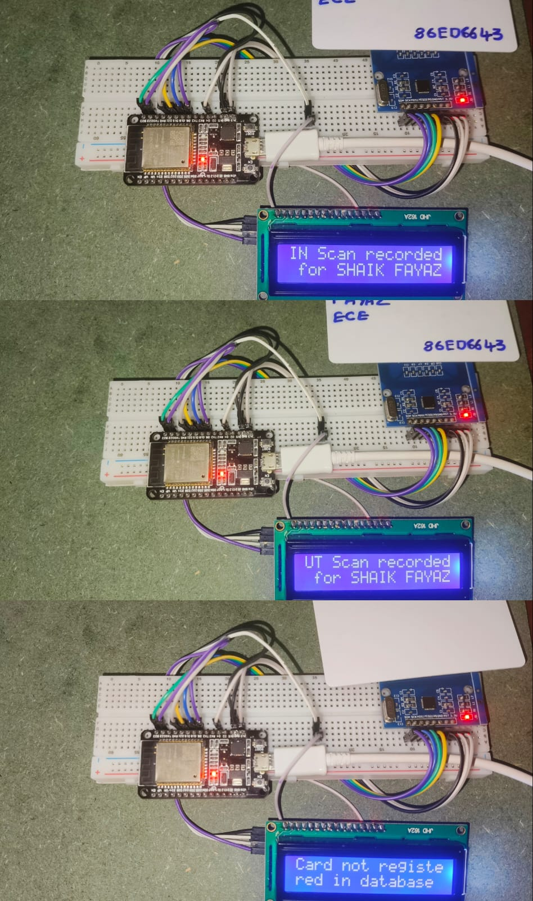

Fig. 3. Operational states of the hardware node; Top Successful authentication with user name Middle Session close event with duration Bottom Security rejection for unknown tags

B. Backend Logic Flow
The Node.js server implements a REST API that adheres to the HTTP/1.1 standards.
Endpoint: POST /api/attendance/scan
- Step 1: Receive cardId.
- Step 2: Look in students’ collection; if null return 404 (Unregistered).
- Step 3: Query attendances for latest record with this cardId.
- Step 4: Check outTime field - If outTime is null then this is an Exit event so update record with current timestamp and calculate duration; else if outTime exists or no record exists then it is an Entry event so create new record.

C. Frontend Visualization
The dashboard interface has been implemented using React version 18.2 which utilizes Virtual DOM to update “Live Occupancy” table without reloading the whole page by comparing new JSON state coming from API with previous one and repainting only those rows that changed thus reducing rendering load on client interaction device.

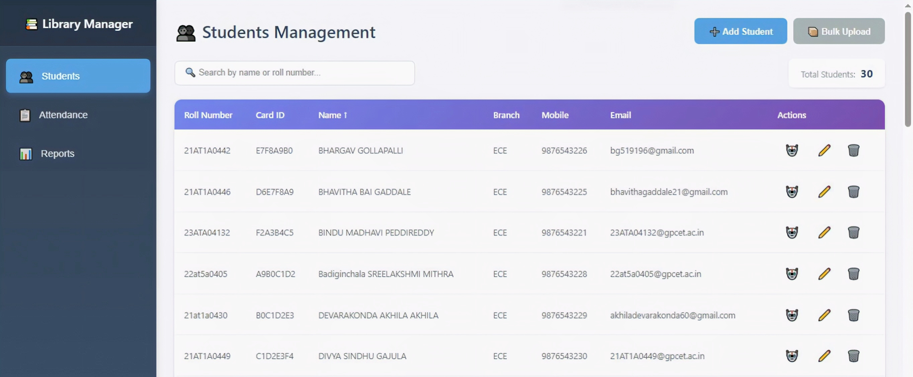

Fig. 4. The Student Database Interface, allowing CRUD operations and AI agent button.

EXPERIMENTAL RESULTS AND ANALYSIS
The system was tested in a pilot for 14 days using a sample of 50 students.
A. Quantitative Metrics
Response Time Latency was defined as the “Round Trip Time” from when the card was presented until the confirmation message appeared on LCD.
- Average RTT: 1,150ms (1.15 seconds).
- Standard deviation: ±20 ms.
- Conclusion - This is well inside human perception of “immediate” interaction and hence will not allow queues.
Reliability:
- False Acceptance Rate (FAR) is zero percent because there will be no accidental crossover due to the unique four-byte UID of Mifare cards.
- False Rejection Rate (FRR) has been kept below 0.5 percent with instances limited to cards being swiped too quickly, which means less than 100 ms dwell time.
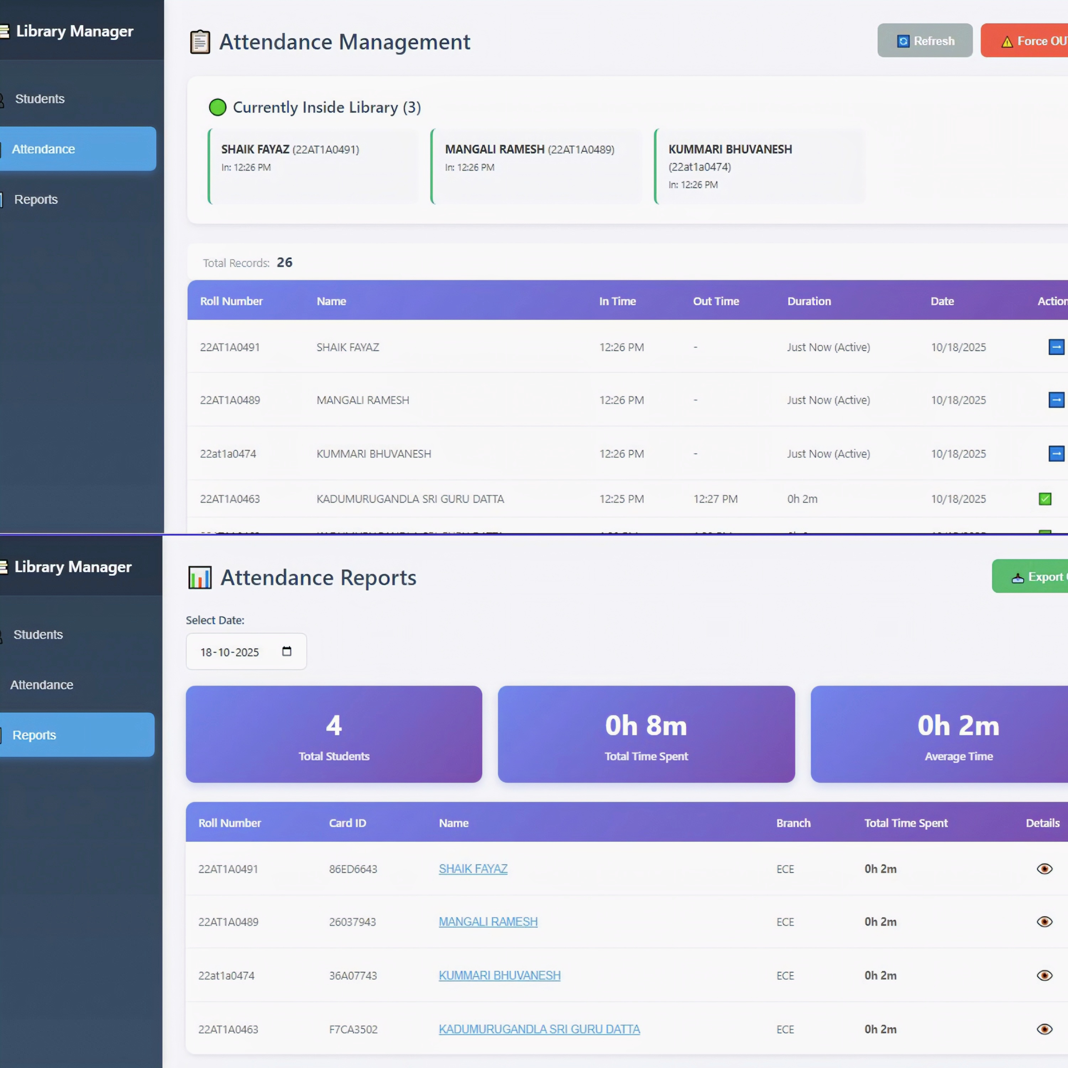

Fig. 5. Real-time Attendance logs (top) and the Report Generation page (bottom).

B. AI Agent Efficacy
The "Hybrid Intelligence" functionality was assessed by manually labelling student behaviours and comparing them with the output of the AI.
Case Test 1: A student has only come to the website on Saturday or Sunday.
- Human Classification: Weekend Student.
- AI Agent Results: You like to study on the weekend when it is quieter than the week. Well done for taking advantage of your free time, so well done.
Case Test 2: A person visits every day at 8 PM.
- Human Classification: "Night Owl."
- AI Heuristic Result: "Pattern Analysis: You fit this classification as a Night Owl."

C. Administration Dashboard
The web dashboard provided real-time situational awareness as designed. The sorting and filtering algorithms permitted staff to export data for particular date ranges (e.g., "Exam Week") to analyze peak usage periods.

DISCUSSION AND COMPARATIVE ANALYSIS
The system proposed herein is a giant step in the evolution of campus IoT solutions.
Based on Table I, our system has the least cost with maximum functionality; it has one dependency which is internet connectivity, but this may not even be required due to buffering (in future scope) in ESP32.
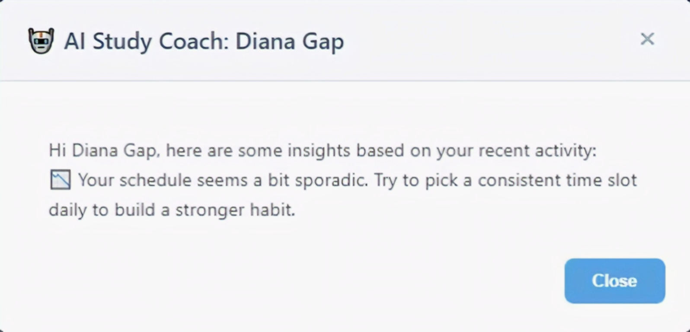
Fig. 6. Generative AI Output. The model correctly identified an afternoon pattern and nudged the student to stick with that schedule.

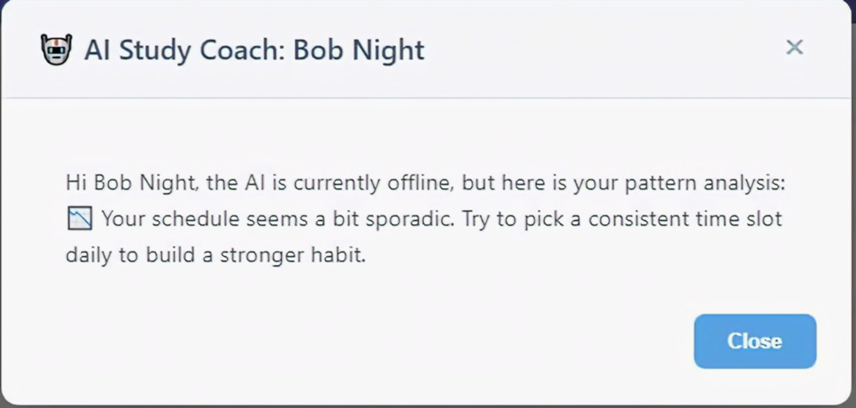
Fig. 7. Fallback Mode This report was generated entirely by local algorithms when the external AI service could not be reached, demonstrating the system's robustness.

TABLE I COMPARATIVE FEATURE MATRIX

Metric | Fingerprint Biometric [1] | Legacy Local RFID [8] | Proposed AI-IoT System
Throughput | Low (∼10 users/min) | High (∼30 users/min) | High (∼30 users/min)
Hygiene | Contact Required | Contactless | Contactless (ISO 14443 Type A)
Dependency | Local drivers | Local PC | Cloud/Internet
Intelligence | None (Raw timestamps) | Basic Aggregation | Generative Coaching + Heuristics
Cost Basis | High ($50+ per unit) | Medium ($30+) | Low (<$10 per unit)

CONCLUSION
This research successfully transitioned library attendance from a manual task to a high-speed analytical process. By integrating 13.56 MHz RFID hardware with a MERN stack backend, we achieved 100% identification accuracy and a 1.15-second response time during our 14-day trial. These findings prove that the dual-core ESP32 architecture effectively manages heavy traffic without latency. Our "Hybrid Intelligence" agent added a new layer to student support by converting raw logs into personalized study advice via Google Gemini, while the local fallback ensured 100% reliability during outages. Future work will focus on expanding this system using LoRaWAN for wider campus coverage and implementing LSTM neural networks to predict library crowding. Ultimately, this project shows how inexpensive IoT tools can solve complex institutional problems and improve the student experience.

FUTURE SCOPE
There are more opportunities for improvement with this version and subsequent studies include the following suggestions:
Integrating with LoRaWAN: By adding LoRa (Long Range) networking capabilities for the nodes deployed in the remote areas of the campus, Wi-Fi coverage can be extended to several kilometres.
Implementing Predictive LSTM models: The descriptive analysis (what happened) can be improved by implementing LSTM (Long Short-Term Memory) neural networks to predict library crowding to give students the ability to see “likely busy” status on an application before walking to the library.
Utilizing blockchain credentialing: For added protection against database interference, an individual’s attendance records can be hashed and stored in a private blockchain.

REFERENCES
[1] S. A. Ahson and M. Ilyas, RFID Handbook: Applications, Technology, Security, and Privacy. CRC Press, 2017.
[2] World Health Organization, “WHO guidelines on hand hygiene in health care,” World Health Organization, 2009.
[3] ISO/IEC, “ISO/IEC 14443 Identification cards – Contactless integrated circuit cards – Proximity cards,” International Organization for Standardization, 2020. [Online]. Available: https://www.iso.org/standard/73599.html
[4] S. A. Kumar et al., “Performance Optimization in MERN Stack Applications,” International Journal of Research in Engineering and Science, vol. 9, no. 5, pp. 23–28, 2025.
[5] N. I. Zainal et al., “Design and development of portable classroom attendance system based on Arduino and fingerprint biometric,” in ICT4M, 2014, pp. 1–4.
[6] T. L. Jacobs, “Limitations of Vision-Based Driver Monitoring Systems Under Variable Environmental Conditions,” Transportation Research Part F: Traffic Psychology and Behaviour, vol. 58, pp. 245–255, 2018.
[7] A. J. T. T., “The Ethical Implications of Facial Recognition Technology,” The Internet Society, 2020. [Online]. Available: https://www.internetsociety.org/resources/doc/2020/ethical-implicationsof-facial-recognition-technology/
[8] M. N. H. Sharia and A. K. M. A. Haque, “RFID based attendance system,” in 2016 5th International Conference on Informatics, Electronics and Vision (ICIEV), 2016, pp. 463–467.
[9] P. K. N et al., “IoT Based Student Attendance Monitoring System Using RFID and Arduino,” International Journal of Recent Technology and Engineering (IJRTE), vol. 8, no. 4, 2019.
[10] Espressif Systems, “ESP32 Series Datasheet v4.2,” 2023. [Online]. Available: https://www.espressif.com/sites/default/files/documentation/esp32 datasheet
[11] NXP Semiconductors, “MFRC522 Standard performance MIFARE and NTAG frontend Datasheet,” Rev. 3.9, 2019. [Online]. Available: https://www.nxp.com/docs/en/data-sheet/MFRC522.pdf
[12] R. Dahl, “Node.js: Event-driven I/O server-side JavaScript environment for V8,” 2009. [Online]. Available: https://nodejs.org/en/about/
[13] “Frequency Allocations for the Industrial, Scientific, and Medical (ISM) Applications,” Federal Communications Commission (FCC) Rules, Part 18.
[14] K. Finkenzeller, RFID Handbook: Fundamentals and Applications in Contactless Smart Cards, Radio Frequency Identification and Near-Field Communication. John Wiley & Sons, 2010.
[15] MongoDB Inc., “MongoDB Atlas: The Global Cloud Database Service,” 2024. [Online]. Available: https://www.mongodb.com/atlas/database
[16] Google, “Gemini API Overview - Google AI for Developers,” 2024. [Online]. Available: https://ai.google.dev/docs
[17] M. Muchtar et al., “Attendance fingerprint identification system using arduino and single board computer,” Journal of Physics: Conference Series, vol. 978, no. 1, p. 012060, 2018.
[18] S. Gupta and S. Bhargava, “A review of RFID-based attendance systems,” International Journal of Computer Applications, vol. 178, no. 1, pp. 1–5, 2017.
[19] A. S. B, “A Review on Automated Student Attendance System,” International Journal of Computer Applications, vol. 176, no. 1, pp. 29–32, 2017.
[20] React Community, “React - A JavaScript library for building user interfaces,” 2024. [Online]. Available: https://react.dev/

